WiFi Training Program
Module 6 – Assignment Questions
- What are the pillars of Wi-Fi security?
The main pillars of Wi-Fi security are authentication, encryption, and integrity. Authentication ensures that only authorized users can access the network. Encryption protects the data transmitted over the air from unauthorized access. Integrity ensures that the data is not altered during transmission. Together, these pillars provide a secure wireless communication environment.
Authentication → verifies user identity
Encryption → protects data
Integrity → ensures data is not altered
- Explain the difference between authentication and encryption in WiFi security.
Authentication is the process of verifying the identity of a user or device before allowing access to the network. Encryption, on the other hand, is the process of converting data into a secure format so that unauthorized users cannot read it. Authentication controls access, while encryption protects the data after access is granted.
- Explain the differences between WEP, WPA, WPA2, and WPA3.
WEP (Wired Equivalent Privacy) is the oldest and least secure, using weak encryption methods. WPA (Wi-Fi Protected Access) improved security with better encryption (TKIP). WPA2 introduced strong encryption using AES, making it more secure and widely used. WPA3 is the latest standard, providing enhanced security features like stronger encryption, protection against brute-force attacks, and improved authentication mechanisms.
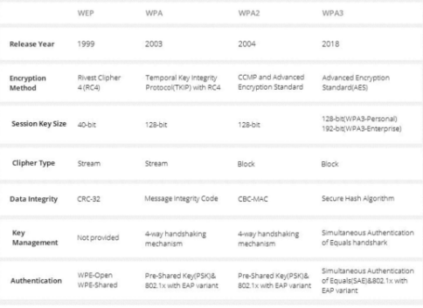
- Why is WEP considered insecure compared to WPA2 or WPA3?
WEP is considered insecure because it uses weak encryption (RC4) and has vulnerabilities in key management. Attackers can easily crack WEP keys using simple tools due to predictable initialization vectors. This makes it unsuitable for modern networks compared to WPA2 and WPA3.
- Why was WPA2 introduced?
WPA2 was introduced to address the security weaknesses of WEP and WPA. It uses AES-based encryption, which is much stronger and more secure than previous methods. WPA2 also provides better data integrity and authentication, making it a standard for secure wireless communication.
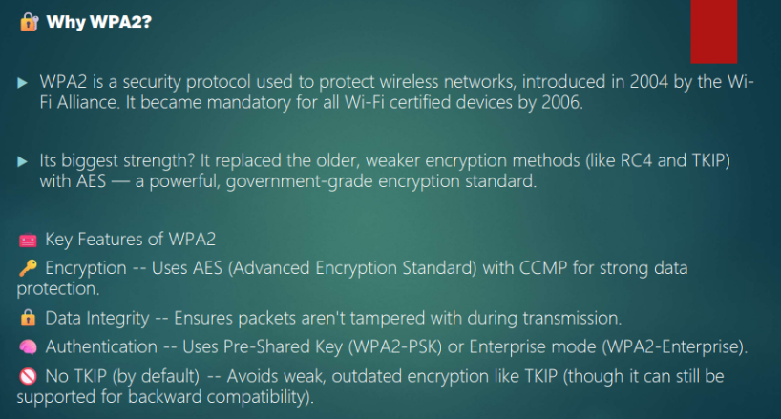

- What is the role of the Pairwise Master Key (PMK) in the 4-way handshake?
The Pairwise Master Key (PMK) is a key used as the basis for generating encryption keys during the 4-way handshake. It is derived from the passphrase or obtained via authentication (like 802.1X). The PMK is not directly used for encryption but is used to generate the Pairwise Transient Key (PTK), which secures communication.
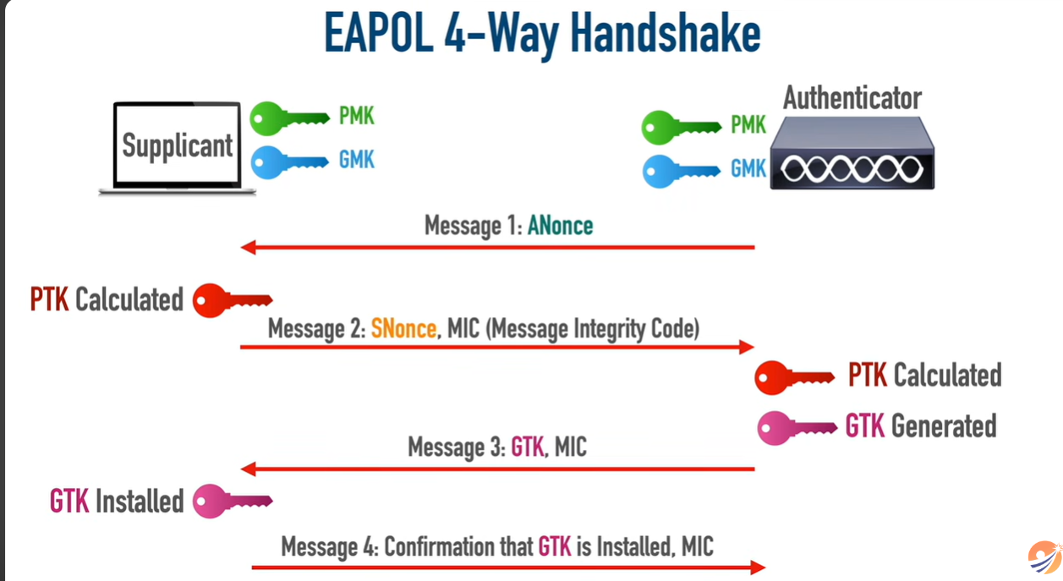
- How does the 4-way handshake ensure mutual authentication between the client and the access point?
The 4-way handshake ensures mutual authentication by allowing both the client and access point to prove they possess the same PMK without directly sharing it. They exchange nonces and derive matching keys independently. If both sides generate the same key, authentication is successful, ensuring secure communication.
- What will happen if we put a wrong passphrase during a 4Way handshake?
If a wrong passphrase is entered, the client and access point will derive different PMKs. As a result, the generated keys will not match, and the handshake will fail. This prevents the client from connecting to the network.
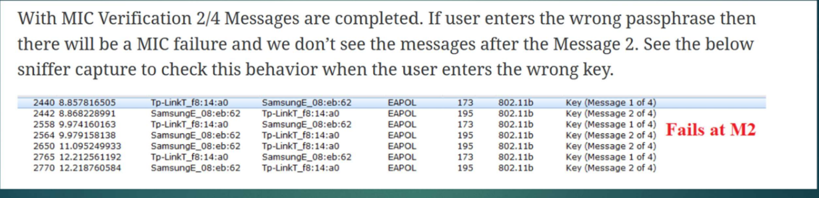

- What problem does 802.1X solve in a network?
802.1X solves the problem of secure network access control by providing a framework for authenticating users before granting access. It prevents unauthorized devices from connecting and supports centralized authentication using servers like RADIUS.
- How does 802.1X enhance security over wireless networks?
802.1X enhances security by using strong authentication methods such as EAP (Extensible Authentication Protocol) and dynamic key generation. It ensures that each user gets unique session keys, reducing the risk of attacks. It also enables centralized management and monitoring of network access, making wireless networks more secure.

